**8 Feb 2019** **The Weekly Bulletin of Rotary Club of Kathmandu Mid-Town** **bc-20.2/019**

|  |
| --- |
| C:\Users\Public\Documents\RIP T1819_EN.png |

District: 3292 Web:www.rotarymidtown.org.np Club Id: 26776

**FEBRUARY IS PEACE AND CONFLICT PREVENTION/RESOLUTION MONTH**

**During February, help build peace and mitigate conflict by:**

- Incorporating conflict resolution and mediation strategies into service projects involving local schools, orphanages, workplaces, and community centers,

- Supporting marginalized groups in risk of violence or persecution by providing relief to those who have fled areas of conflict,

- Participating in fellowship and service activities with Rotary clubs in other parts of the world to promote greater international understanding,

- Recruiting candidates for a [Rotary Peace Fellowship](https://www.rotary.org/en/our-programs/peace-fellowships). Up to 100 peace fellowships are offered annually at Rotary Peace Centers at universities around the world.

**Club’s Weekly Meeting # 1475 held on Friday 1 Feb 2019**

Guest speaker Raj Kharel supported by Ms Rita Kharel talked about Brahmasthani Awareness Society and Om Disabled Child Care Home, the two NGOs providing health care and shelter to people with disabilities and abandoned by families. They also provided some insights into their next project ‘OM Center’ a shelter with modern equipment and therapeutic facilities for rehabilitation of people with disabilities and preparing them for reintegration into the society.

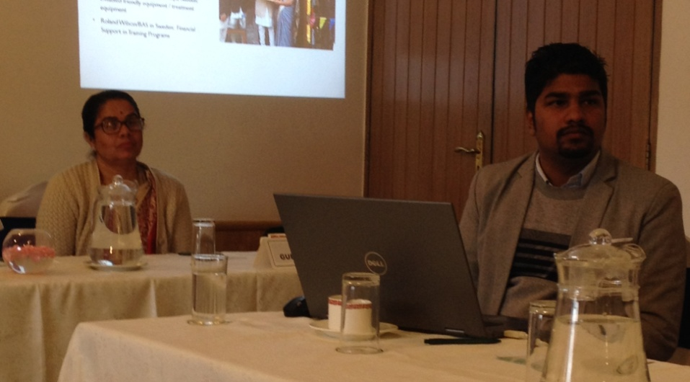 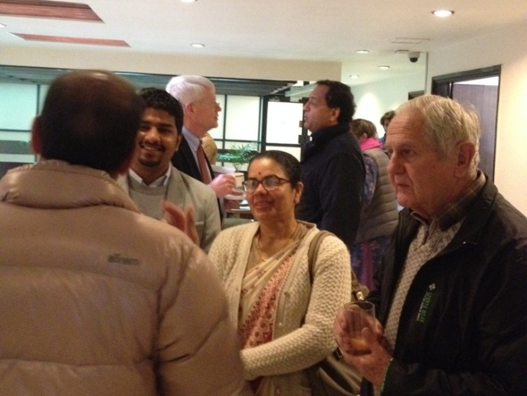

Guest speaker Rita Kharel/Raj Kharel on session Guest speakers on fellowship with Mid-Towners

**Club Meeting # 1476 Friday 8 Feb**

Guest speaker Dr Poonam Rajya Laxmi Rana will give a talk on "Cross cultural study on ethnic community Yi of China with Tharu ethnic community of Dang/Deokhuri of Nepal, similarities and differences".

Dr Poonam, Associate Professor in the Dept of Nepalese History, Culture & Archaeology in Tribhuwan University, did her PhD in Nepalsese History Culture & Archaeology and her Master’s Degree in Sociology (Gold Medalist) from TU. She also did Master’s Degree in Environment & Ecology from Delhi. She was ‘Visiting Scholar’ to Sichuan University, Chengdu in 2016, and ‘Visiting Project Scholar’ at Yunnan Minzo University, Kunming, China in 2017.

She has published numerous articles on Nepalese culture and archaeology. She has two books ‘Nepalese Ethnic Costumes & Ornaments’ and ‘Cast Hierarchy & Livelihood of Baji Ethnic Group & Animistic practices among Tharus of Dang & Deokhuri’ on her credit.

**RID 3292 District Conference 2019:**



**11th District Conference is scheduled to be held in Butwal, 22 - 24 February 2019.**

Registration fee (Rs) Jan 1-Feb 15 2019 Spot Registration

Rotarian/Guest 6,500 7,000

Rotarian with non-Rotarian spouse 12,000 13,000

Rotaract/Interact/RCC 3,000 3,500

For more information, contact:

Rom Sharma (Conference Office Secretary); districtconference019@gmail.com

Tanka P. Pokharel (Registration Sub-Committee Chair): mobile: 9857021325

**Cloths Donated**

PP Dr Chandra Lekha Tuladhar and Rotaract President Sushma Shrestha handed over a suitcase full of old cloths to children of brick factory workers in a small program at Bungmati on Friday 1 Feb. The program was also witnessed by Ms Rita Kharel/Raj Kharel of BAS, our guest speakers in the morning meeting. The old cloths were donated by Mr Stephen Kotats and Ms Susanne Bellinhausen (Berlin/Germany) through Mid-Towner Dr Isabella Khadka. PP Dr Chandra Lekha also took the opportunity to talk to local school teachers emphasizing need of teaching school children on small matters of good behavior besides text books.

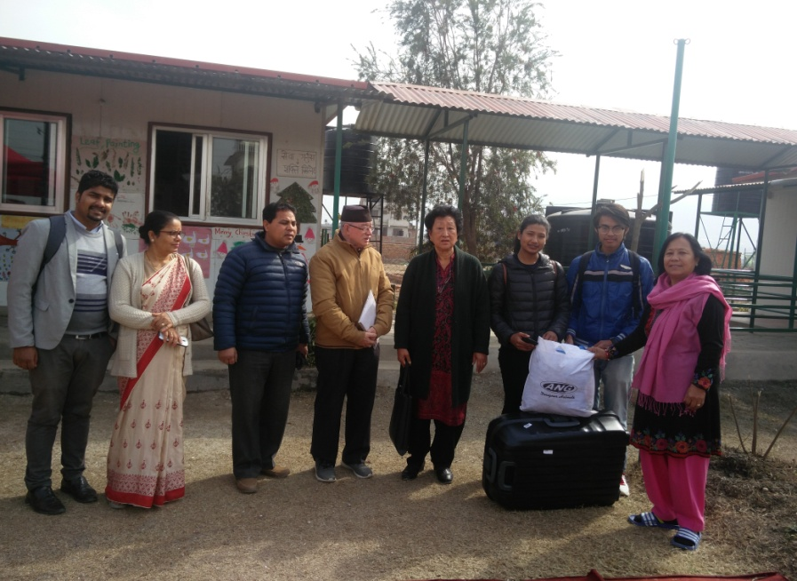 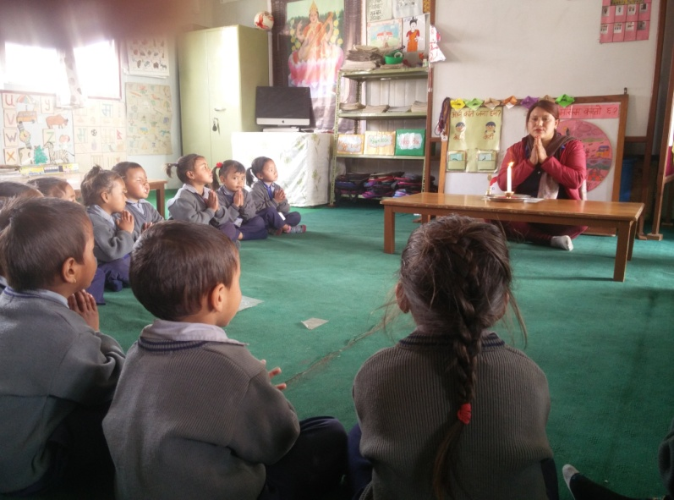

Photo courtesy: PP/Dr Chandra Lekha Tuladhar

**Economics of Peace**

The Institute for Economics and Peace, a leading think tank dedicated to developing metrics to analyze peace and to quantify its economic value, has developed an innovative methodology to calculate the economic impact of violence to the economy. It does this by calculating 13 different types of violence related spending at the national level, and applying a multiplier effect to account for the lingering influence of violence and fear. There are immediate and obvious examples of the impact of violence to the economy, like hospital fees, or security costs, and there are also more subtle long term impacts, such as a shift to more defensive spending by individuals, businesses and governments.

*Read more on http://economicsandpeace.org*

**Members’ Corner:** *(This column is for Club members to express anything they would like in matter of Club activities, Club administration, Club issues or on Breakfast Chatter, or on anything else that would be of interest to fellow members.)*

PDG Yogendra Pradhan writes:

Thanks for the nice Breakfast Chatter. It would have much more comprehensive as well as informative, if you had covered the reports of the Projects recently visited by some of our active members. This would have been encouraging to those members who could not make out to visit our sites this time and may be they will make their minds to visit our projects next time. Just a suggestion please. Yogi

**Do you Know** **?**

**Skin-crawling worm!**

Even horror movies aren't this gross. When a Russian woman found a small lump below her left eye, she didn't think it was particularly concerning. But after the lump began to move above her eye and then into her lip, she sought medical attention. Doctors removed a thread-like worm known as *Dirofilaria repens*, which naturally infects dogs, cats, foxes and other wild mammals . The worms spread through mosquito bites and typically live in the tissue under the skin. Humans, it turns out, are just accidental hosts that the worm had no intention of defiling.

*Read more on https://www.livescience.com*

**A THOUGHT FOR THE DAY**

“Kindness is doing something good for someone and not expecting anything in return, ever!”

- Anonymous

On Lighter Side:

One day a golfer, playing a round by himself, is about to tee off, and a greasy little salesman runs up to him, and yells, "Wait! Before you tee off, I have something really amazing to show you!"

The golfer, annoyed, says, "What is it?"

"It's a special golf ball," says the salesman. "You can never lose it!"

"Whattaya mean," scoffs the golfer, "you can never lose it? What if you hit it into the water?"

"No problem," says the salesman. "It floats, and it detects where the shore is, and spins towards it." "Well, what if you hit it into the woods?"

"Easy," says the salesman. "It emits a beeping sound, and you can find it with your eyes closed."

"Okay," says the golfer, impressed. "But what if your round goes late and it gets dark?"

"No problem, sir, this golf ball glows in the dark! I'm telling you, you can never lose this golf ball!"

The golfer buys it. "Just one question," he says to the salesman, "Where did you get it?"

"I found it!"

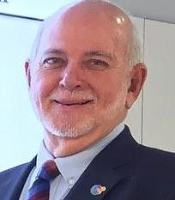

… … It's about having the curiosity, the courage, and the conviction to look at different paths

that might be better — whether you're out for a stroll on a beautiful Bahamas morning, or

helping chart the course for our organization.

**RI President Barry Rassin**

Please send information on club activities, progress reviews on service projects, relevant photos etc to:

BC Editor: RR Shrestha email: rryesrr@gmail.com

## 8 Feb 2019 The Weekly Bulletin of Rotary Club of Kathmandu Mid-Town bc-20.2/019